**Sustainable Innovation**

**Project Title :** TinFly Music/Video Player for Blind

**Description :**TinFly is a Tkinter based Python GUI project developed for blind and disables.

As not every person in this world is as able to self sustain him/herself by making one’s end, Tinfly aims to provide source of entertainment to the one’s that are not as abled in the world.

The Main Objective of the TinFly is to spread happiness and source of entertainment to disables so as to make them provide more for little efforts of automation.

**Basic Idea of Project :** Create Music/Video Playlist,Automate Video/Music Playing by gestures and voice commands.Read/listen Audio Books in app. Communicate through sign language via inbuilt draw tool.

**Problem Statement :** Create a Python GUI Application for disable people to automate entertainment providing websites by gestures,voice and text.

**Features:**

TinFly includes various features which apply basic to complex Python

concepts which include :

• Gesture Controls

• Voice Controls

• Playlist Creation

• Audio Book

• Sign Language Communicator

• Video Downloader

• WhatsaApp Messaging

• Database Connectivity

Idea/Product Implementation :

<https://github.com/MihirRajeshPanchal/Music-Player-For-Blind>

**Idea Designs**

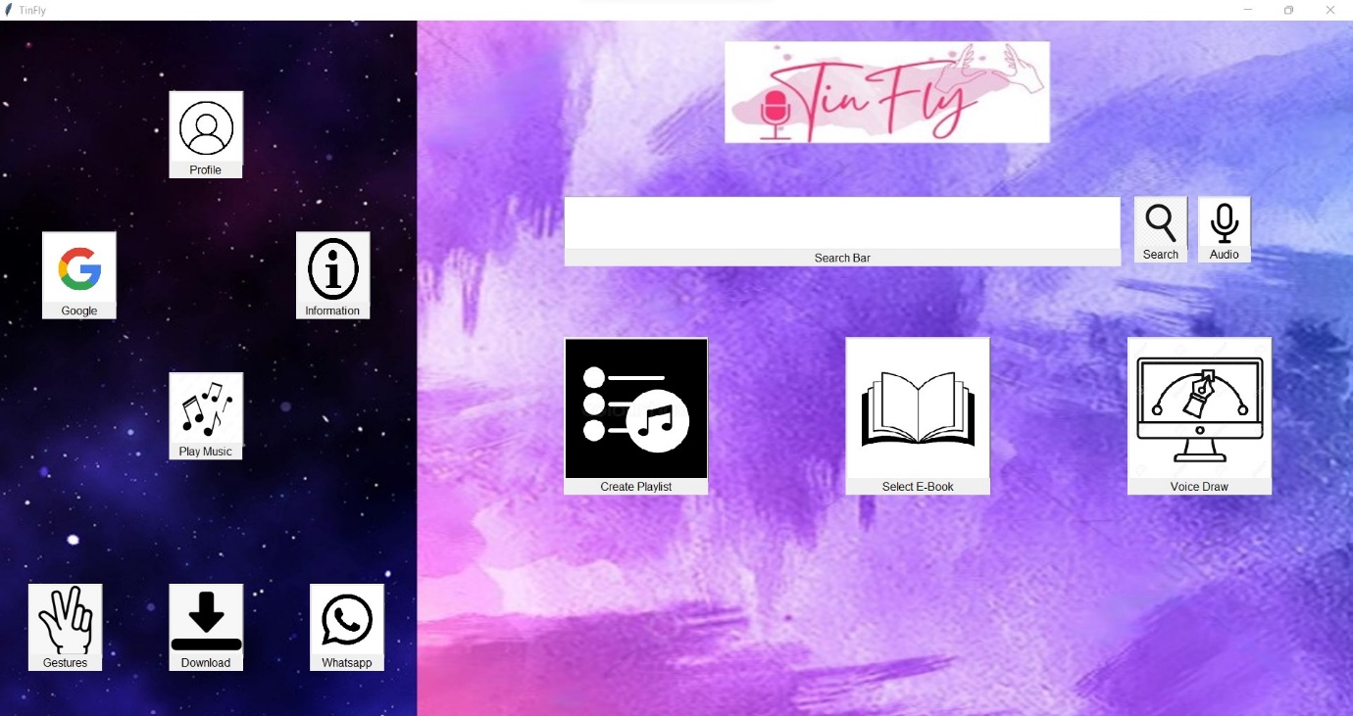

The Home Page of the Application

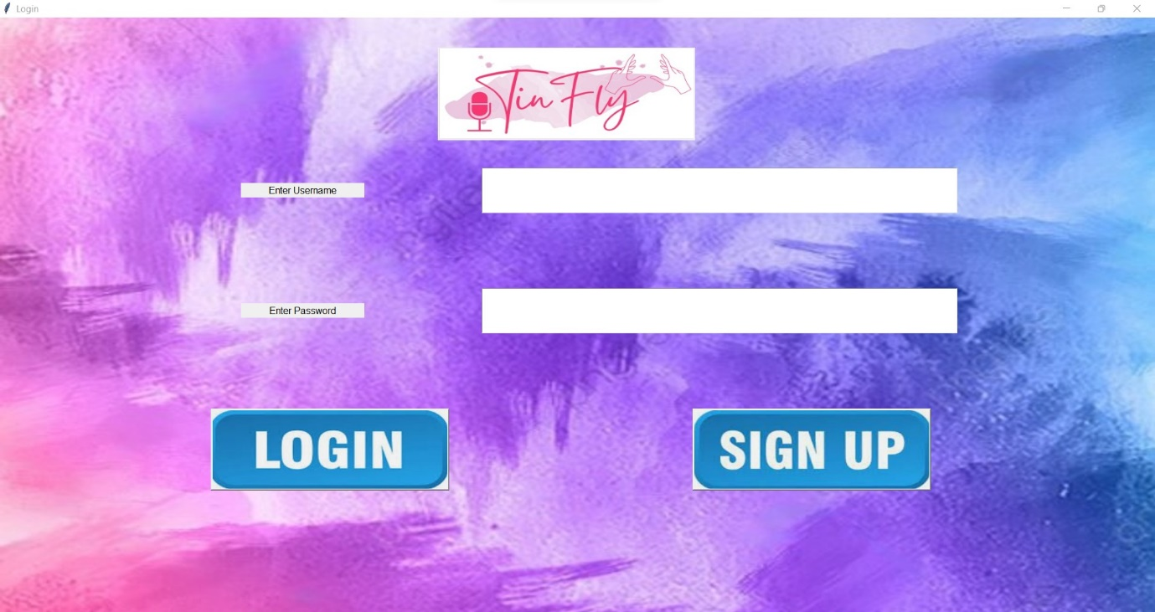

Login and Sign Up Page of Application

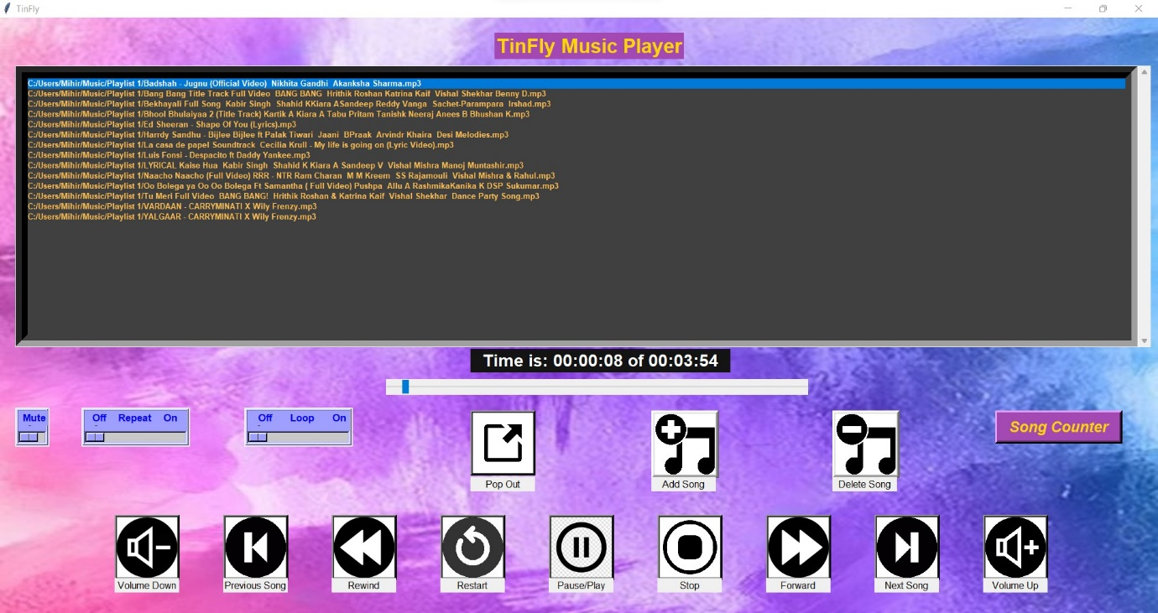

Music Player of the Application

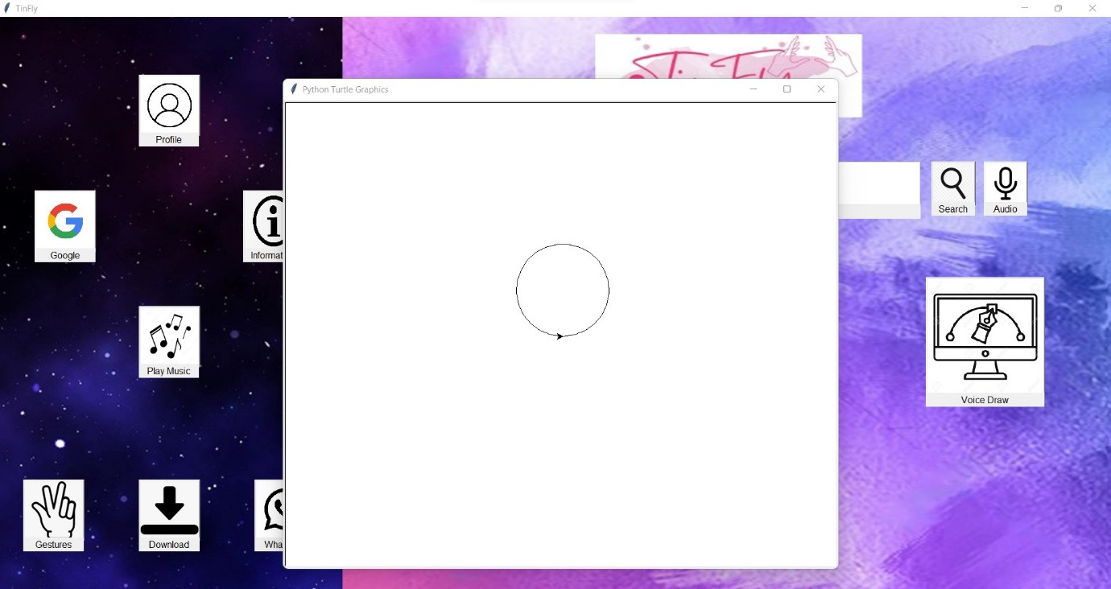

Draw shapes and alphabets via sign language and voice commands

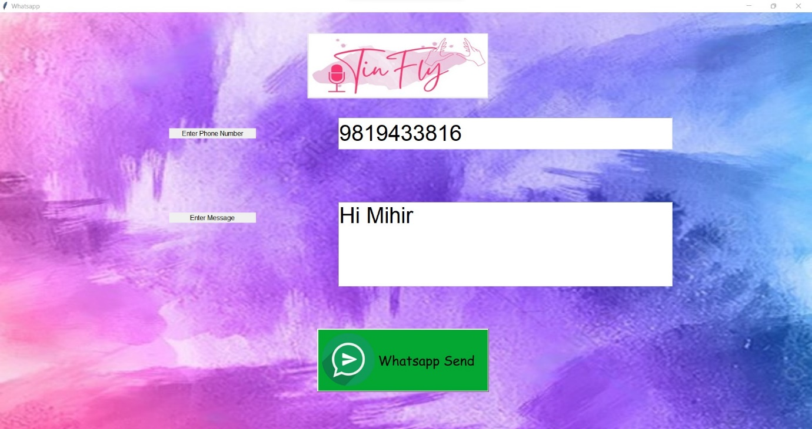

Inbuilt WhatsApp message sending feature

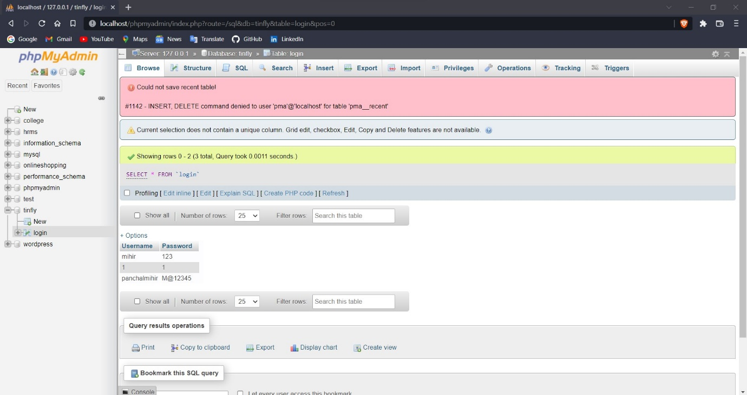

Backend Database for Application

**Gesture Controls:**

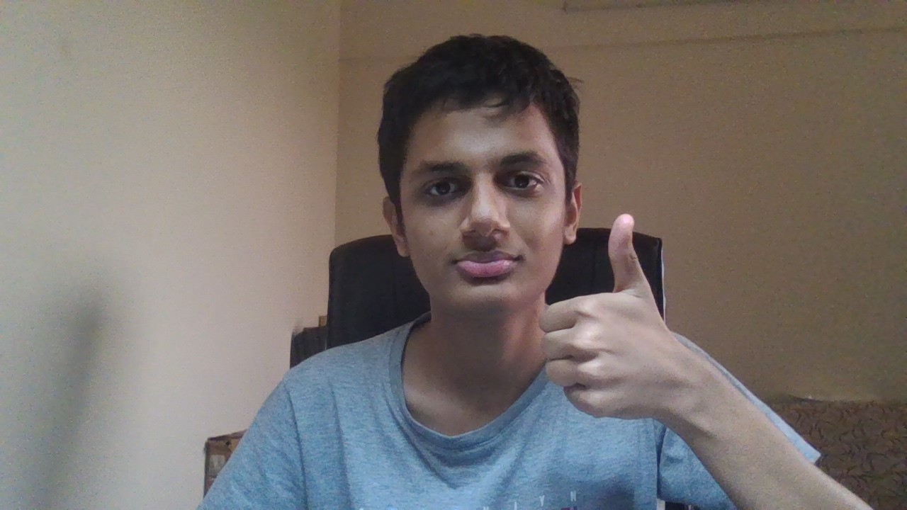

Thumbs Up

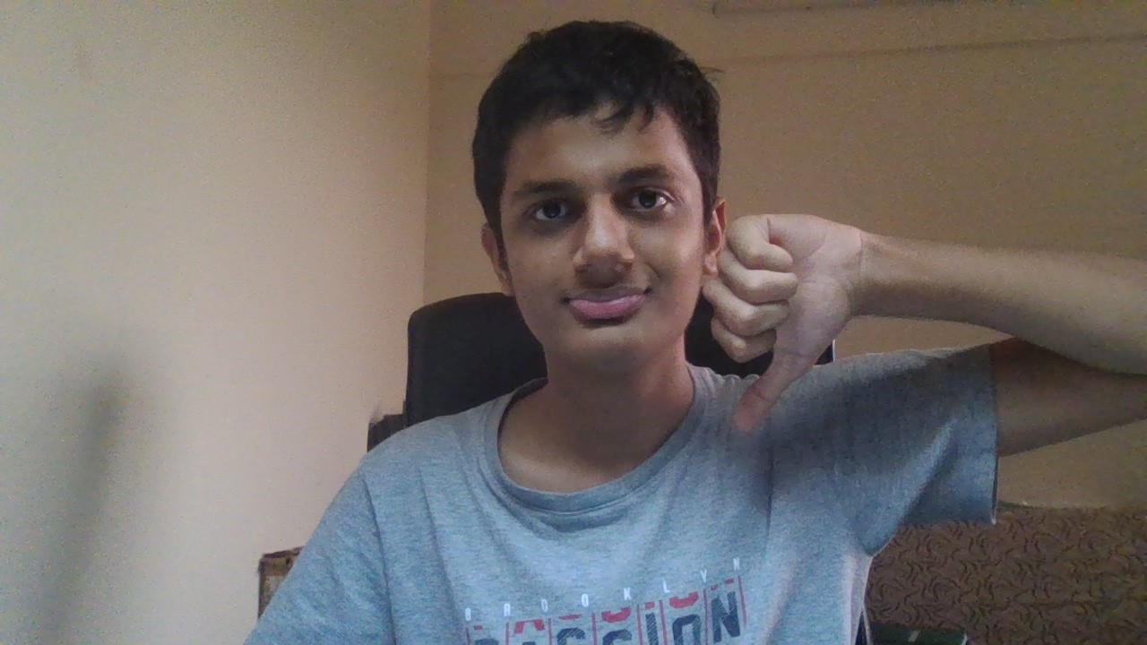

Thumbs Down

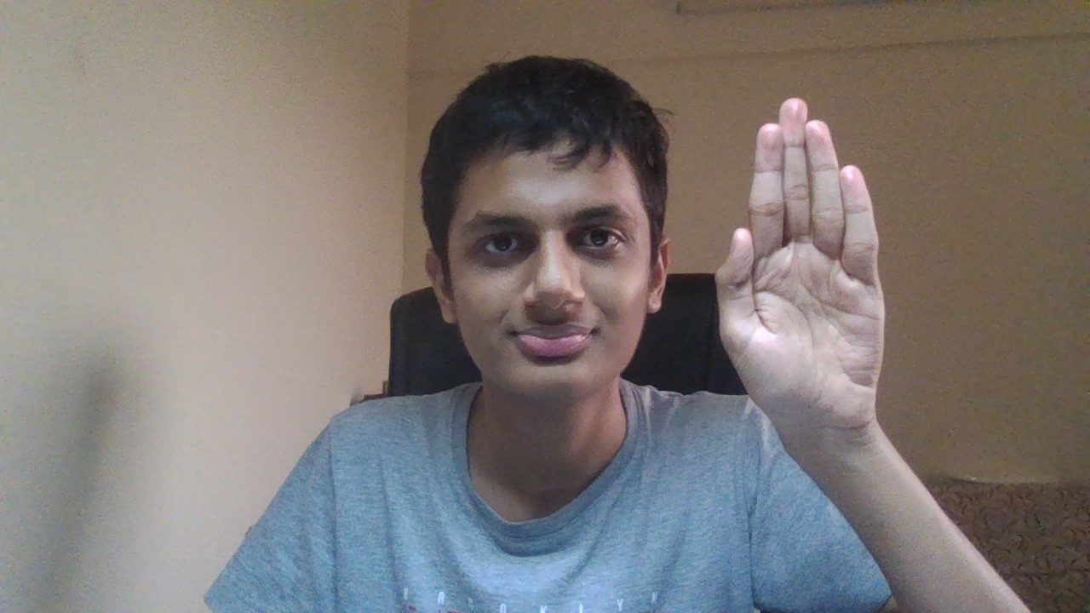

Stop

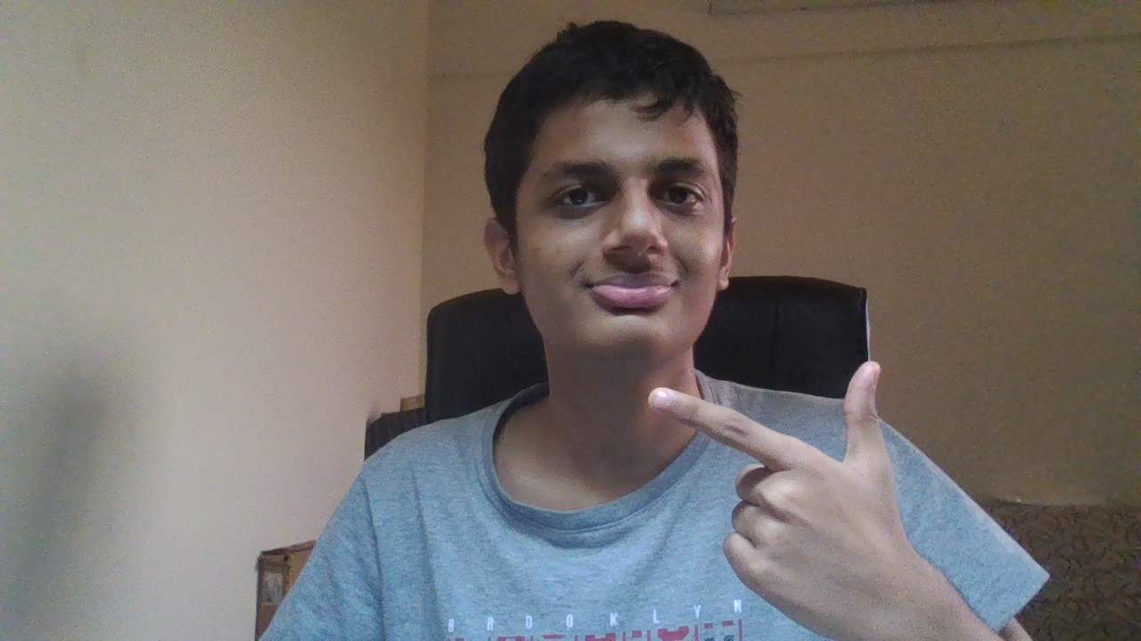

Smile

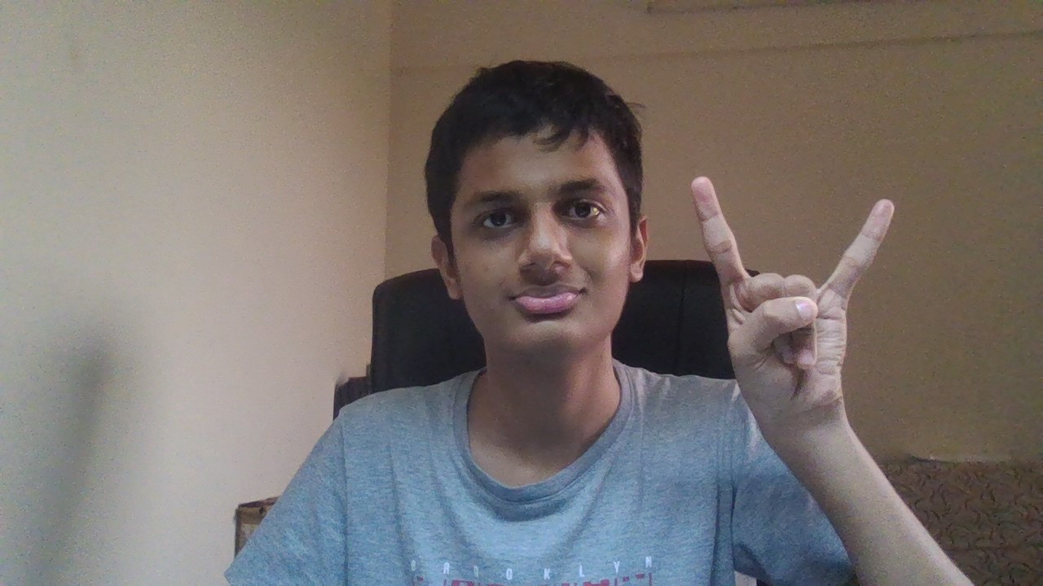

Rock

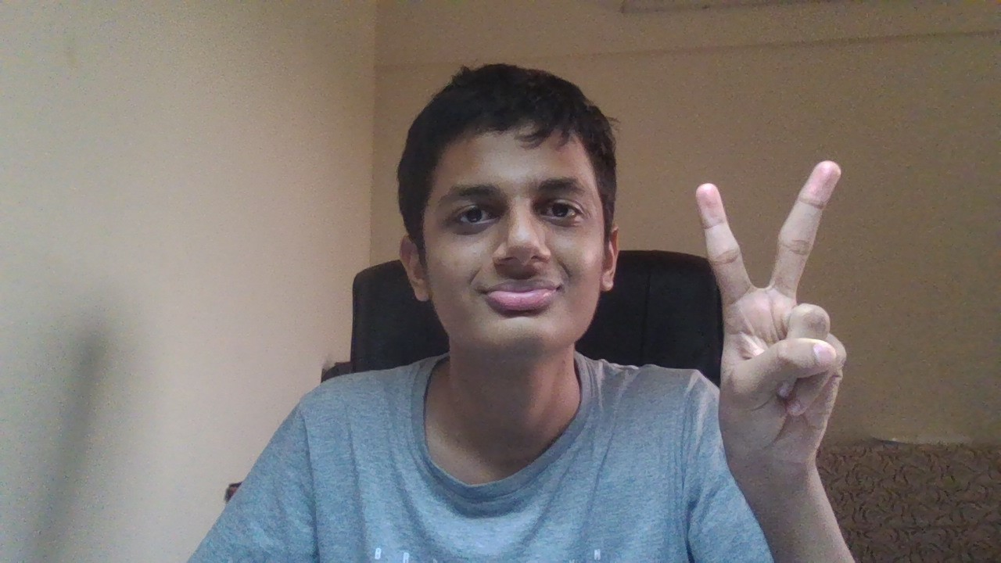

Peace

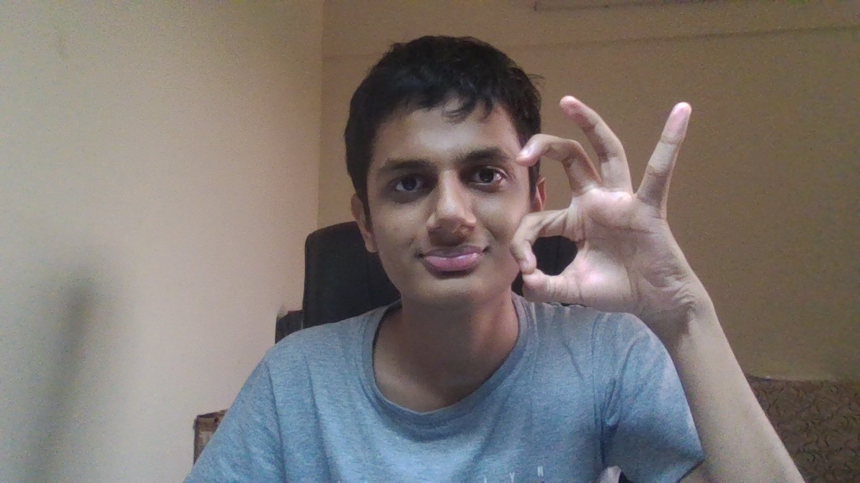

Okay

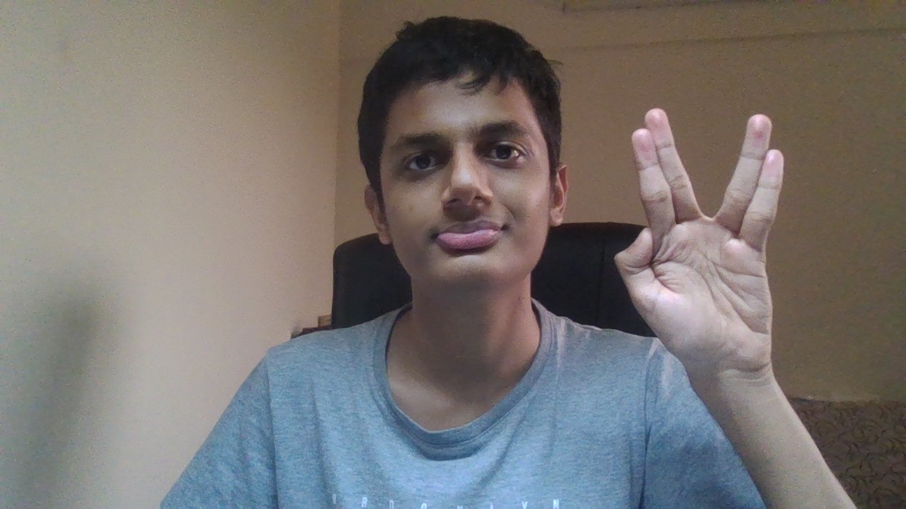

Live Long